**LINUX**

* Linux is a billion-dollar corporation nowadays. Thousands of governments and companies are using Linux operating systems across the world because of lower money, time, licensing fee, and affordability. Linux can be used within several types of electronic devices. These electronic devices are easily available for users worldwide.
* Linux Distributions:
  + Deepin
  + OpenSUSE
  + Fedora
  + Solus
  + Debian
  + Ubuntu
  + Elementary
  + Linux Mint
  + Manjaro
  + MX Linux

What is Operating System?

* Operating System is an interface between user and computer hardware. Computer hardware cannot understand human language and human cannot understand computers binary language. Binary language is nothing but 0’s and 1’s.
* Types of Operating System:
  + Windows OS
  + Linux OS
  + Unix OS

**Architecture of Linux:**

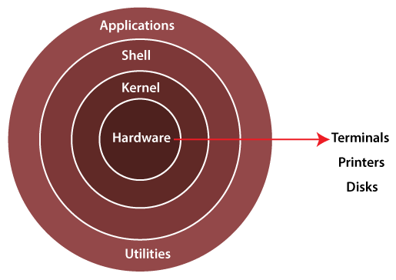

* Kernal:
  + The kernel is one of the core section of an operating system. It is responsible for each of the major actions of the Linux OS. It can schedule the task, manage the resources, Control the security.
* Shell:
  + It is an interface between the kernel and user. It can afford the services of kernel. It can take commands through the user and runs the functions of the kernel.
  + Shell takes input from the user and Interpreter the command and gives output to the user.
* Applicaitons:
  + Applications are nothing but utilities.

**File System in Linux Operating System**

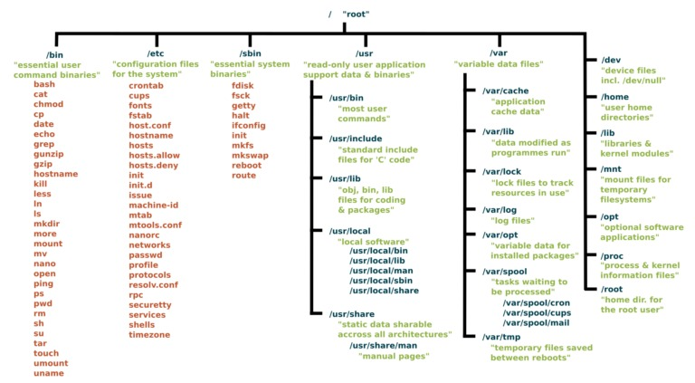

**File Permissions**

* File permissions are displayed in:
  + Numerical representation
  + Symbolic representation

$ ls -l

drwxr-xr-x. 4 root root 68 Jun 13 20:25 tuned

-rw-r--r--. 1 root root 4017 Feb 24 2022 vimrc

When Linux file permissions are represented by numbers, it's called numeric mode. In numeric mode, a three-digit value represents specific file permissions (for example, 744.) These are called octal values. The first digit is for owner permissions, the second digit is for group permissions, and the third is for other users. Each permission has a numeric value assigned to it:

* r (read): 4
* w (write): 2
* x (execute): 1

For example, a file might have read, write, and execute permissions for its owner, and only read permission for all other users. That looks like this:

* Owner: rwx = 4+2+1 = 7
* Group: r-- = 4+0+0 = 4
* Others: r-- = 4+0+0 = 4

The results produce the three-digit value 744.

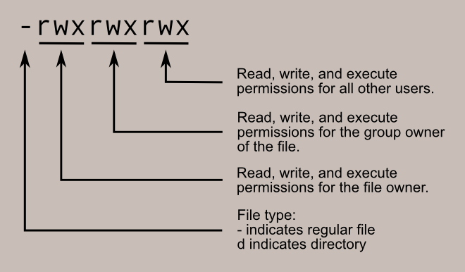

* When we create normal file, user default permissions are --> 664
* While you create file in root user permissions are --> 644
* When you create directory in root user, default permission is --> 755
* When you create directory in normal user, default permission is --> 775

umask will sets the permissions for the linux file system.

002 --> ubuntu

022 --> root

777 -------> folder/directory

777 – 002 = 775 in normal user(ubuntu)

777 – 022 = 755 in root user

666 -------> files

666 – 002 = 664 = normal user

666 – 022 = 644 = root user

* Chmod command is used to change the permission of the file/folder.
* By default, execution is not available. Using chmod we can change the permissions.

**Package Manager**

* A package manager in Linux is a tool that allows users to install, remove, upgrade, configure, and manage software packages on an operating system.
* Common package manager in Linux:
* dpkg (Debian Package Manager)
* APT (Advanced Package Tool)
* rpm (RedHat Package Manager)
* yum (Yellowdog Update Modified)
* dnf (Dandified Yum)

### **APT**

Using APT to Manage Packages in Debian and Ubuntu

* **Distributions ---->** Ubuntu, Debian, and Kali Linux
* **Commands ---->** apt, apt-get, apt-cache
* **Underlying package management tool ---->** [dpkg](https://linux.die.net/man/1/dpkg)
* **Package file format ----->** .deb

### **DNF**

Using DNF to Manage Packages in CentOS/RHEL 8 and Fedora

* **Distributions:** RHEL/CentOS 8, Fedora 22, and later versions of both distributions
* **Commands:** dnf, yum
* **Underlying package management tool:** [RPM](https://linux.die.net/man/8/rpm) (*RPM Package Manager*)
* **Package file format:** .rpm

### **YUM**

Using YUM to Manage Packages in CentOS/RHEL 7 and Earlier

* **Distributions:** RHEL/CentOS 7, Fedora 21, and earlier versions of both distributions
* **Command:** yum
* **Underlying package management tool:** [RPM](https://linux.die.net/man/8/rpm) (*RPM Package Manager*)
* **Package file format:** .rpm

**COMMANDS**

|  |  |  |
| --- | --- | --- |
| **Command** | **Sub command** | **Description** |
| **ls** |  | **ls command is used for list the directories in present working directory** |
| **ls -la** | **ls -la will show all hidden file. e.g(.ssh)** |
| **ls -l** | **It will show the count and details of files** |
| **man** |  | **man command gives documentation of the mentioned command**  **e.g: man ls** |
| **cd** |  | **It is used to navigate the directory** |
| **touch <file name>** |  | **It will create the file** |
| **touch file(1..20).txt** | **It will create 20 files. e.g: file1, file2 ..... file20** |
| **mkdir <folder/dir name>** |  | **used to check the present working directory** |
| **clear** |  | **Used to clear the screen** |
| **mkdir <folder/dir name>** |  | **Used to create folder/directory** |
| **mkdir -p <foldername1/foldername2>** | **This command is used to create Folder/Directory inside the Directory** |
| **cat <file name>** |  | **It is used to display the Data inside the file** |
| **cat > file1.txt** | **It allows you to append data by terminal to file** |
| **cat >> file1.txt** | **It allows you to append another data to the file** |
| **cp <filename> <path>** |  | **Copy the file from one location to another location** |
| **mv <filename> <path> path = /home/ubuntu/folder1** |  | **Moves file from one location to another location** |
| **mv options <oldfilename> <newfilename> options= -v (verbose)** |  | **Rename the file** |
| **rm <filename>** |  | **Removes the file** |
| **rm -rf <foldername>** | **Removes folder having content** |
| **rmdir** | **Deletes the folder it is empty** |
|  |  |  |
| **who** |  | **\* It is used to show the logged in user in server**  **\* It shows Login time, Information about terminal** |
| **whoami** |  | **It will display logged username. No other details will get** |
| **w** |  | **this command is used for all login user information in server** |
| **id** |  | **this command is used to get the information of user id and**  **group id of logged in user** |
| **echo** |  | **this command is used to display the message in terminal** |
| **echo $SHELL** | **will display the which environment varibale using** |
| **printenv** |  | **Prints all the environment variable in server** |
| **uname** |  | **Display the OS name** |
| **uname -a** | **Display more details of the OS like IP address, Distribution name** |
| **ln** |  | **This command is used to create link in linux operating system**  **\* while file details are started by - it is normal file**  **\* if it is started by l -> lrwxrwxrwx it is link file**  **\* if it is started by b -> block file** |
| **ln -s <existingfilename> <filename>** | **filename will linked to existingfilename** |
| **less** |  | **To display the file output in page wise**  **\* If you want to go last page use b**  **\* If you want to go line by line you can use enter**  **\* If you want to go line by line you can use enter Key**  **\* for exit from the page use q** |
| **more** |  | **less and more command are similar but has simple difference**  **\* Here in more command we can't go backward but in**  **less command we can go backward and forward.** |
| **head** |  | **This command will display top 10 lines by default** |
| **head -n 20 /etc/passwd** | **If you want to display lines as you want use -n**  **e.g: cat -n /etc/passwd | head -n 20**  **(cat -n) [-n] used to display line no.** |
| **tail** |  | **This command will display bottom10 lines by default** |
| **tail -n 20 /etc/passwd or tail -20 /etc/passwd** | **We can display bottom lines as you want** |
| **cat -n /etc/passwd |head -n 20 |tail -n 7** | **If you want to get the middle lines** |
| **grep <value> <filename>** |  | **grep command used to fetch the values by matching pattern** |
| **grep -i <value> <filename>** | **This command is used to fetch value if it is upper/lowercase**  **character by matching pattern** |
| **df** |  | **df command used to check disk space/free space available**  **(only numbers we can see e.g 480876)** |
| **df -h** | **It will display in understandable format (shows 480M)** |
| **du -sh /home/** |  | **Display the disk usage of perticular folder** |
| **whereis ls** |  | **Display the binay location of any command** |
| **hostname** |  | **check the hostname of the server** |
| **wget <url>** |  | **Download the binary or files from the internet using**  **wget htttp://file.txt.com/download/** |
| **curl** [**https://www.google.com**](https://www.google.com) |  | **curl command used to send / transfer the data to server** |
| **sudo** |  | **to get the root privileges** |
| **ps** |  | **ps command is used for display the running processes** |
| **ps -aux** | **diplay all processes which is running** |
| **kill -pid** |  | **It is used to kill the process which is running e.g: kill -9 here 9 is processid[PID]** |
| **ifconfig** |  | **Get the information about erthernet card.**  **To run this command install net-tools**  **sudo apt install net-tools** |
| **ifconfig <ethernet name>** | **If you want to display 1 ethernet details e.g: ifconfig eth0** |
| **date** |  | **Get the date and time from the server** |
| **tree /home/** |  | **used to display the output in tree format. display the folder structure in tree format**  **install tree command to execute**  **sudo apt install tree** |
| **route** |  | **To display the route table and to setup default gateway in the linux server** |
| **alias d="du -sh"**  **alias update ="sudo apt update"** |  | **It is used to make command-line interface more user friendly**  **it will give anothe name to the command. we can use that command for further usage.** |